1) **How to compare two JSON have same properties without order?**

1. **Let obj1 = {name:” person 1”, age:5};**
2. **Let obj2 = {age:5, name:” person 1”};**

**Solution on below Image:**

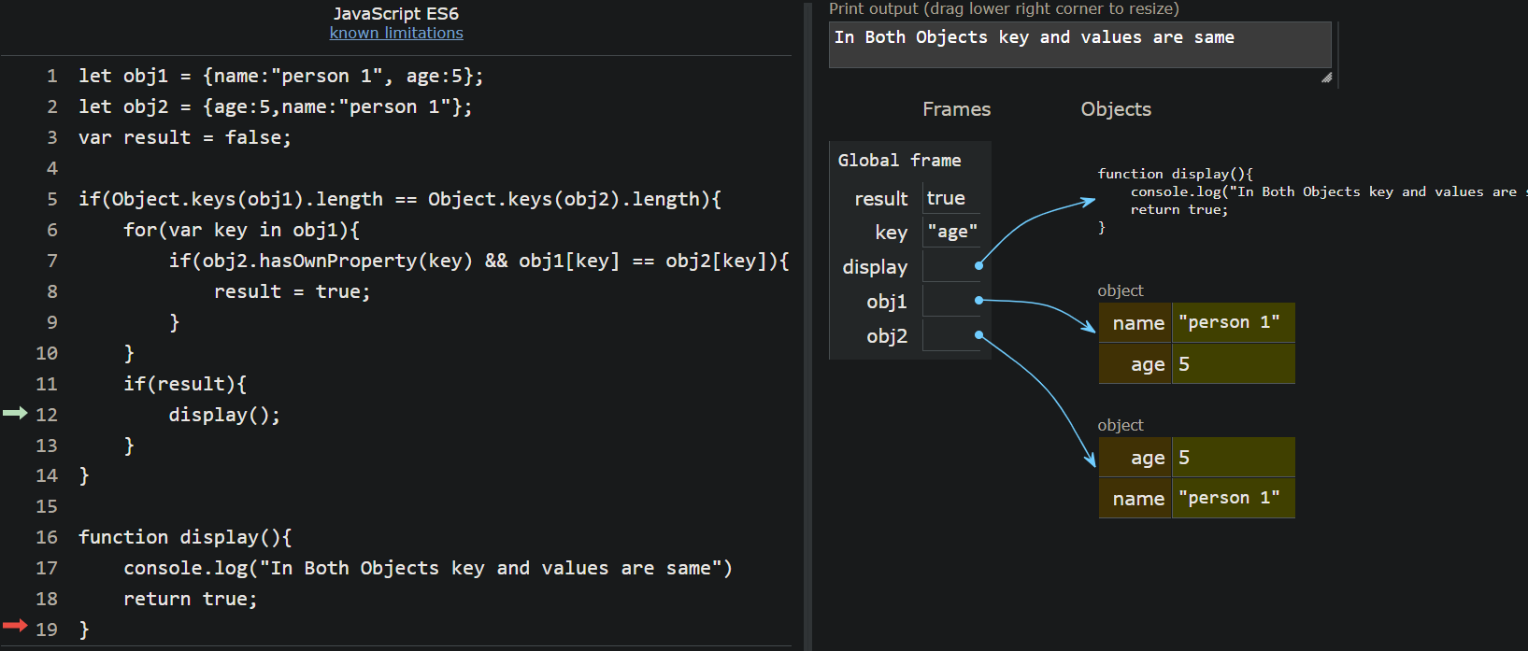

**let obj1 = {name:"person 1", age:5};**

**2 let obj2 = {age:5,name:"person 1"};**

**3 var result = false;**

**4**

**5 if(Object.keys(obj1).length == Object.keys(obj2).length){**

**6 for(var key in obj1){**

**7 if(obj2.hasOwnProperty(key) && obj1[key] == obj2[key]){**

**8 result = true;**

**9 }**

**10 }**

**11 if(result){**

**12 display();**

**13 }**

**14 }**

**15**

**16 function display(){**

**17 console.log("In Both Objects key and values are same")**

**18 return true;**

**19 }**

**2) using rest API to show flags in console?**

**<html>**

**<head>**

**<title>Xml Http Request</title>**

**</head>**

**<body>**

**<script>**

**// to create xml http request**

**var xhr = new XMLHttpRequest();**

**// http method define**

**var method = "GET";**

**var url = "https://restcountries.com/v3.1/all";**

**//request open**

**xhr.open(method,url);**

**//request onload**

**xhr.onload = function(){**

**if(xhr.status == 200){**

**//request was sucessful**

**var details = JSON.parse(xhr.responseText);**

**//console.log(details); //--- to see data**

**for(var i = 0;i <= details.length - 1;i++){**

**console.log(details[i].flag);**

**}**

**}else{**

**//request was unsucessful**

**console.log("Request failed:",xhr.status);**

**}**

**};**

**// send request**

**xhr.send();**

**</script>**

**</body>**

**</html>**

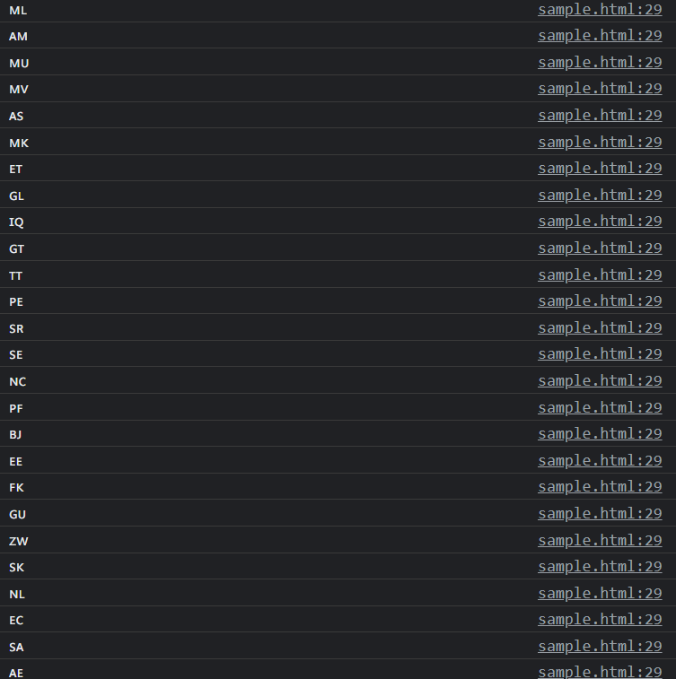**based on browser version and type it will be differing flag name or flag image in output**

**3) show country name, region, sub region and language using rest URL?**

**<html>**

**<head>**

**<title>Xml Http Request</title>**

**</head>**

**<body>**

**<script>**

**// to create xml http request**

**var xhr = new XMLHttpRequest();**

**// http method define**

**var method = "GET";**

**var url = "https://restcountries.com/v3.1/all";**

**//request open**

**xhr.open(method,url);**

**//request onload**

**xhr.onload = function(){**

**if(xhr.status == 200){**

**//request was sucessful**

**var details = JSON.parse(xhr.responseText);**

**console.log(details); //--- to see data**

**for(var i = 0;i <= details.length - 1;i++){**

**var lang = "";**

**if(details[i].hasOwnProperty("languages")){**

**var languageNames = Object.values(details[i].languages);**

**lang = languageNames;**

**}else{**

**lang = "";**

**}**

**console.log("Name of the Country:"+details[i].name.official +"\n" +**

**"Region of the country:" + details[i].region + "\n" +**

**"Sub region of the country:" + details[i].subregion + "\n" +**

**"Country languages:" +lang + "\n" +**

**"Country Populations:" + details[i].population );**

**}**

**}else{**

**//request was unsucessful**

**console.log("Request failed:",xhr.status);**

**}**

**};**

**// send request**

**xhr.send();**

**</script>**

**</body>**

**</html>**

**Output:**

